# Create account

In order to use the application, all users must create an account with a unique username and a password specifying his/her personal information (email, full name, affiliation, personal website and domain of interest).

Steps to create an account in the application:

1. Click the Create account button on the main screen

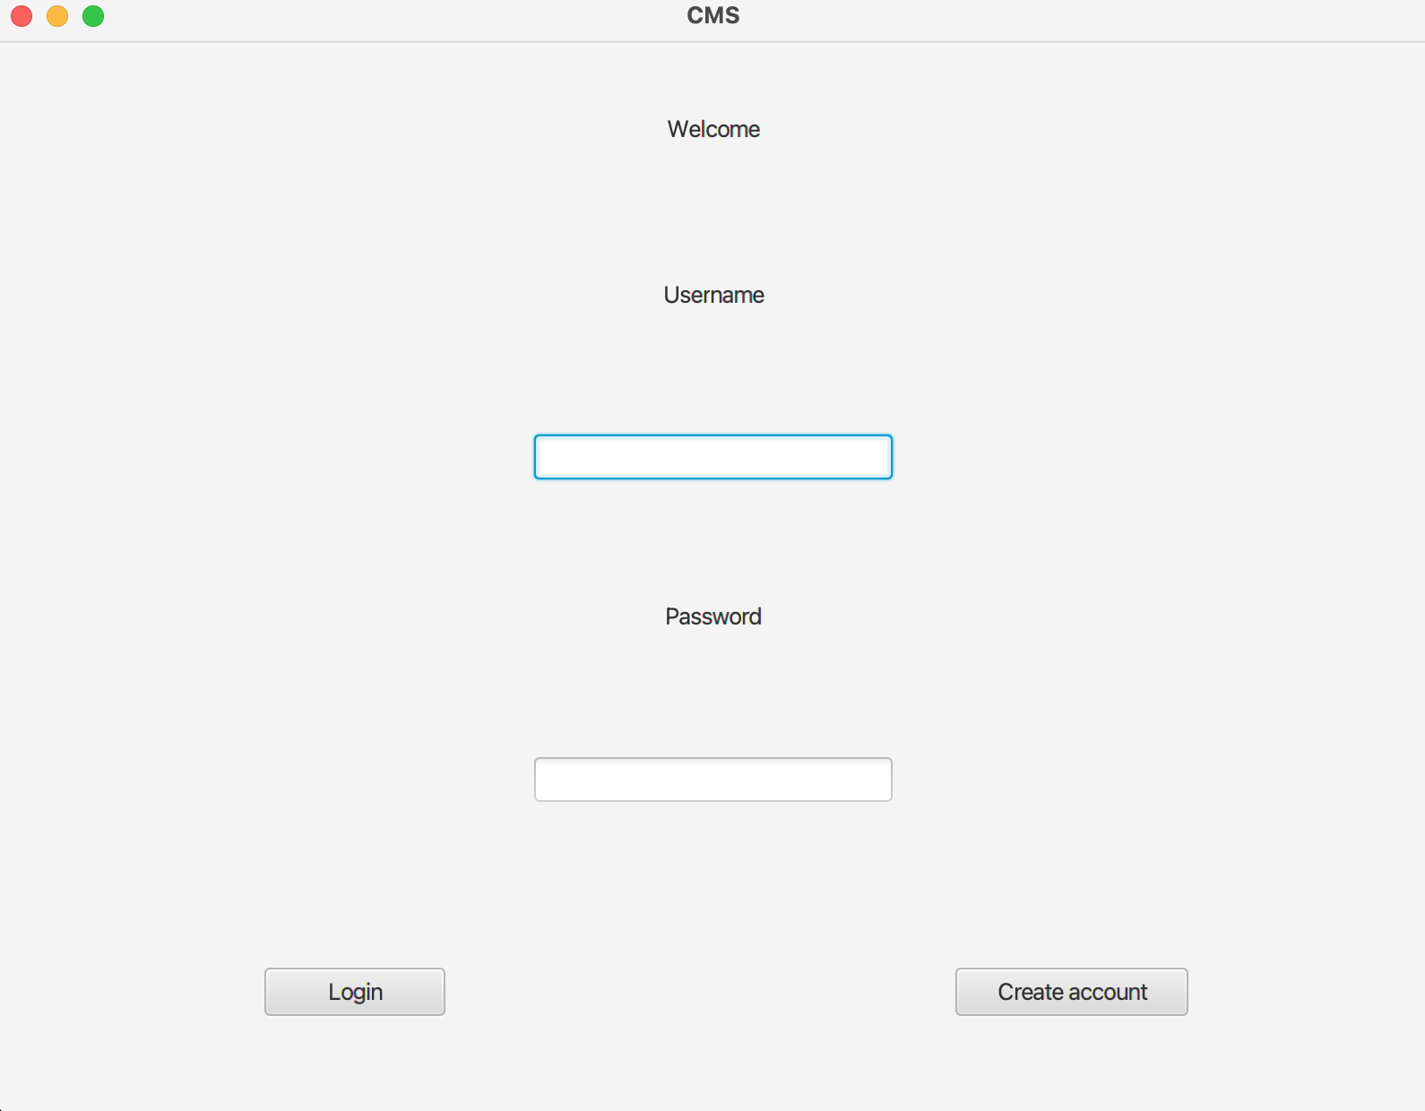

1. Type your information in all the fields
2. Click the create account button
3. A notification will appear: 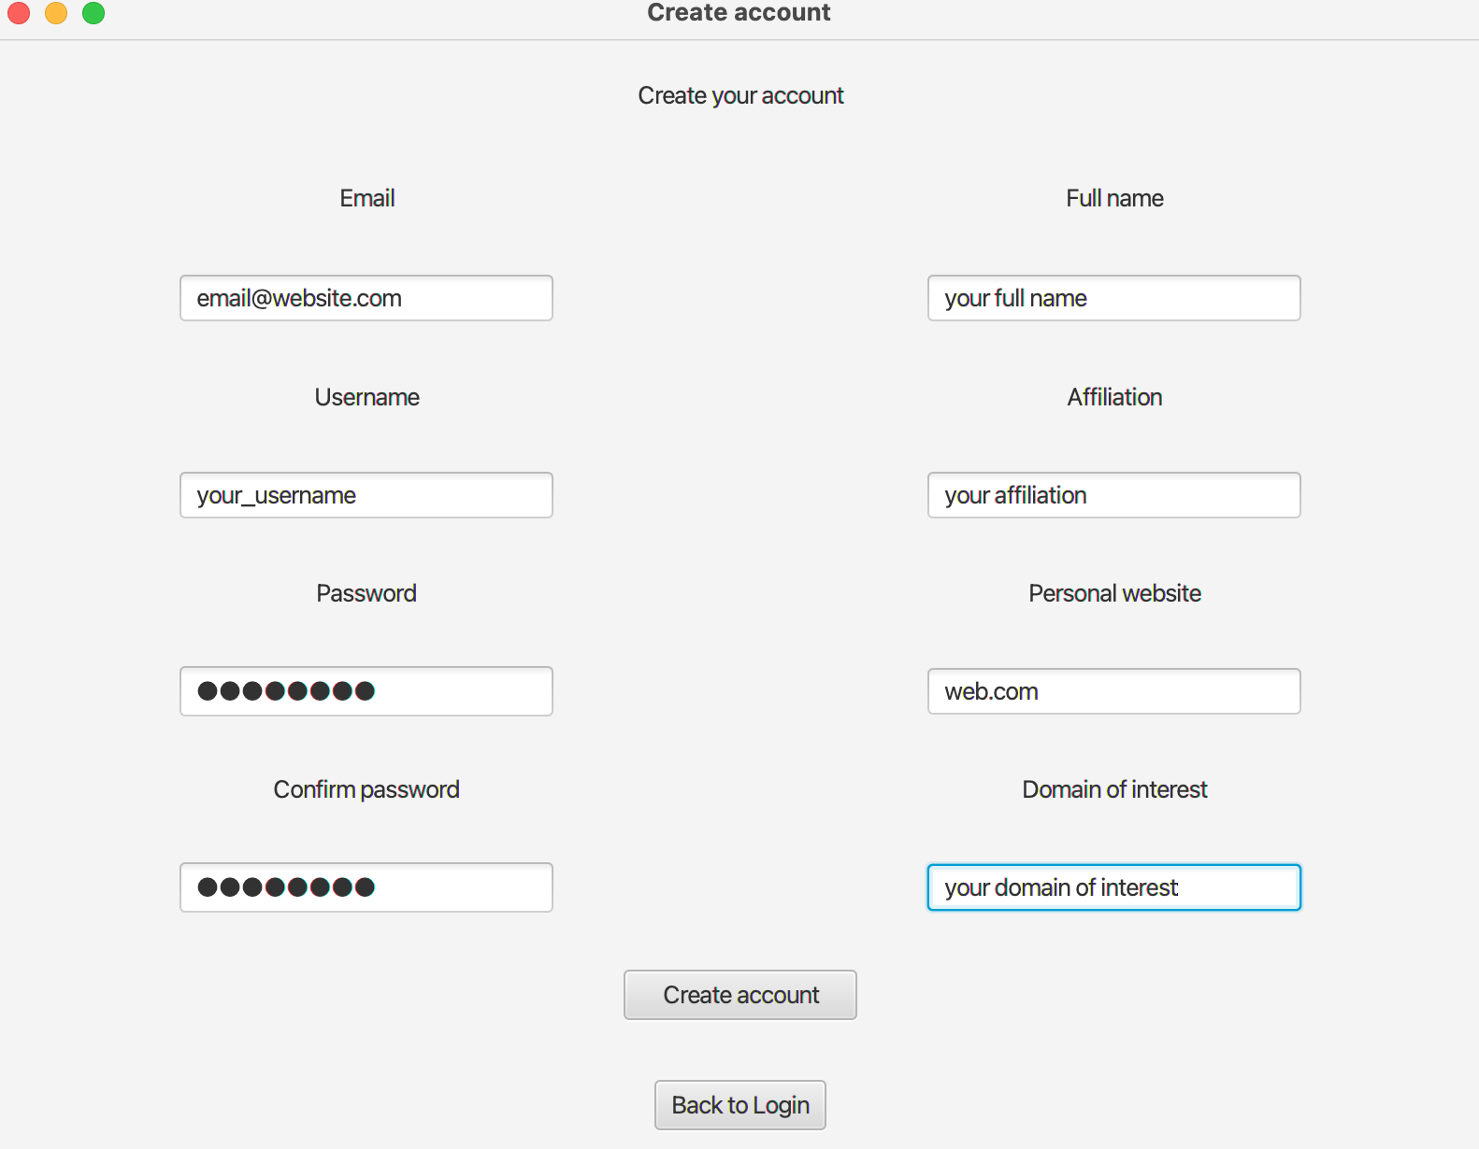

* If the message states a successful creation of the account, 
* click the OK button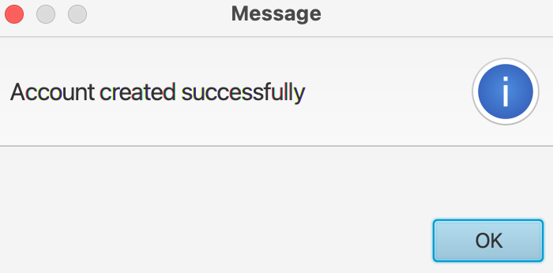



* Click the Back to Login button and you can log in





* The operation will fail if :
* the username already exists
* the passwords don’t match
* empty fields exist

* In this case, click the OK button on the error card and try creating your account again

